SHOPPING, FINANCE AND LIFESTYLE
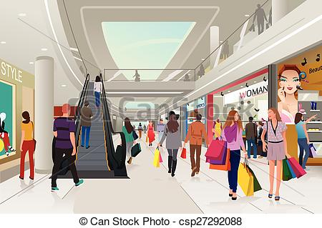
We live in a society where we can buy everything we want. Buying and selling goods is probably a regular human activity. That means that we also have different types of shops and places where you can find them. A shopping centre is a large covered area or building where you can find lots of shops selling different things – for example, clothes, books, toys, shoes and sports equipment. A department store is one large shop with several floors or departments that sells different things – for example clothing on one floor, electronics on another floor. And the third one a high street is a street with a lot of shops on it. You can walk along the street and visit the shops. If you want to buy just grocery and things for daily use you visit supermarket or grocery shop. In places with shops you can see that shops are divided according to what they sell. Greengrocers sell fruits and vegetables. A bakery sells bread, cakes or rolls. A butcher sells different types of meat. A pet shop is a shop that sells everything you need for your pet, such as food, treats and toys. A shoe shop specialises in shoes and boots. A electronics shop sells everything you need for your computer, printer or sells electronic equipment. A hardware shop like OBI or Bauhaus sells things for your house and garden. There are sweet shops, tobacconists, clothing shops, chemists, bookshops, jewellers, toy stores, second-hand shops.
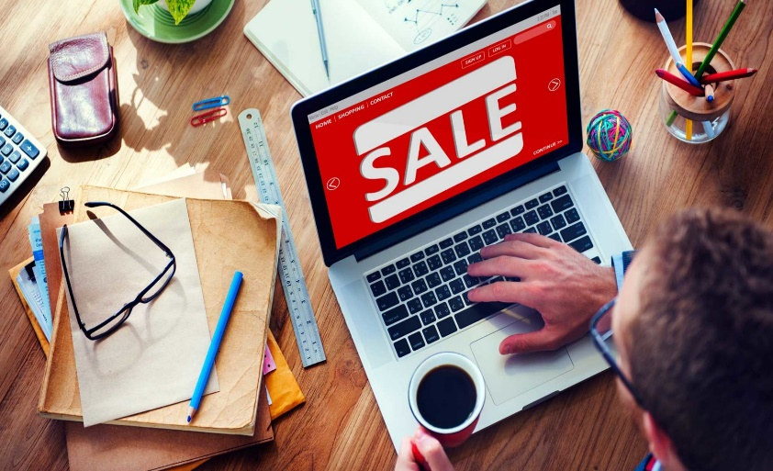
If you don't like to be with a lot of people at one place, you will welcome online shopping. In these days you can buy everything on the internet and sometimes a selection is better, easier to choose and shops from all over the world. The downside is that you might get a wrong product, wrong size or the product may not come, you can’t actually see the goods you’re buying, you have to know how to use the Internet fairly well, and you have to wait to receive the goods in the mail or by special delivery. Internet shopping is good for people who can’t get to the shop. Also you don’t have to fight with crowds or wait in long queues. But is bad because it means people are not shopping in traditional shops anymore and independent shops are closing. Sites like rohlik.cz or damejidlo.cz are focused on groceries and prepared dishes. Advantage is that you don't have to go out and they bring the food to your home.
In small towns like Varnsdorf there is not large selection and residents normally go to a big city like Prague or Liberes because there is more choice. These cities has a large shopping centre with everything under one roof, all in one place. But if you are looking for better quaility, then calm local shops are better. They are friendlier and sell products that you can’t buy everywhere.
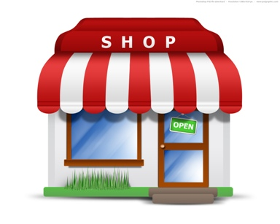
A chain of shops means many shops owned by the same company. They all have the same name and sell the same products – for example, Starbucks, Tesco or H&M. Independent shops are owned by individuals and are usually smaller. They sell different and unique products that you can’t buy in other places.

When comes the time to pay, in most places you can choose if you would like to pay in cash or by card. With card you don't have to be afraid of carrying a lot of money and it’s easier and safer. In cash you know exactly how much you have to spend and sometimes you don’t spend as much.
If you would like to work in shops you can apply for in different positions. The cashier is the person who works at the cash desk where you pay and manipulte with money. A shop manager runs the store and has high status. A sales assistant is someone who helps customers if they have a question or find things and try on clothing. A shopkeeper is someone who owns a small independent shop. In large shops, like hypermarkets, the owner is a corporation, so there is just a manager in each shop . A merchandiser or buyer is someone who selects which products the store will buy or sell. Security guards are people who keep the shop safe and prevent people from stealing goods.
As the shopping is very available, people sometimes have that feeling that they want more and more things and they start to be big consumers. Consumer society is a society in which the buying and selling of goods and services is the most important social and economic activity. But sometimes is it just buying especially goods that they do not need, and in which a high value is placed on owning many things.
All stores use advertising to make them more visible. They want to attract attention and the best way are sales. A sale or discount is when goods are sold for a lower price than the original, when you can buy something for half price or get some money off the product. Big sales are usually on after Christmas, at the end of summer or when the shops are trying to sell leftover stock. The next way to attract attention is using bloggers to promote their products through their social media as Instagram, Facebook or YouTube channel. These days Instagram is the most widespread platform and can influence a lot of people.
For a lot of people shopping is a regular activity and hobby. It is part of the everyday life and for somebody is it some kind of relax.
Vocabulary
Goods | Zboží | Bakery | Pekařství
Department store | Obchodní dům | Butcher | Řezník
Greengrocer | Zelinář | High street | Hlavní ulice
Grocery shop | Potraviny | Independent shop | Nezávislý obchod
Chain of shops | Řetězec | Cash | Hotovost
Consumer society | Konzumní společnost | Advertising | Reklama
Sale | Prodej / Výprodej | Shop keeper | Vedoucí prodejny
Merchandiser | Obchodník | Buyer | Kupující
Cashier | Prodavač | Shop manager | Manažer obchodu
Security guard | Ochranka | Leftover stock | Zbývající zásoby

