Food and gastronomy
Czech cuisine
Czech cuisine is not just the healthiest. Meat is one of the most important ingredients. It’s used most commonly pork, beef, poultry or rabbit. Czech cuisine specializes in sauces and dumplings. Czech cuisine is also known for its beer. Czech beer is world-famous and has a long tradition. Czechs consider it a national drink.
Traditional Czech cuisine
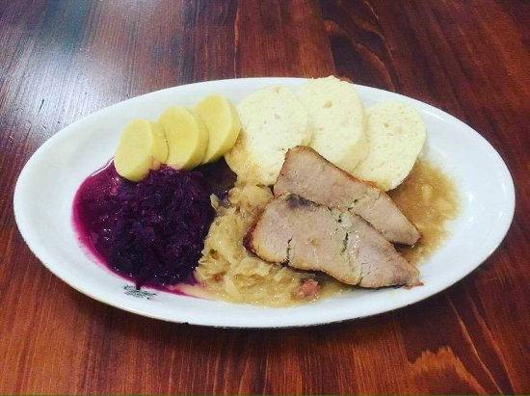
- Vepřo knedlo zelo (roasted pork) - is basically roasted pork served with dumplings and a side of pickled cabbage.
- Česnečka (garlic soup) – garlic soup served with croutons, it also contains a raw egg, which is added near the end of the cooking process and left alone to cook in the heat of the soup. Small pieces of sausage, pork or cheese are sometimes added to.
- Rajská omáčka (Beef on tomato soup) – this is beef on tomato sauce The sauce is made using a mix of chopped tomatoes and tomato paste, to which already cooked beef, onions and a number of spices are added.
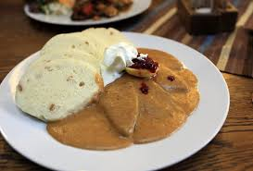
- Svíčková na smetaně (marinated sirloin) – this popular dish consists of braised beef covered with a thick, creamy sauce of parsley root and carrots. It’s usually served with a side of cranberry sauce and whipped cream.
- Řízek (schnitzel) – schnitzels aren’t exclusively Czech. Schnitzels are unique in that they can be made using a number of different meats, covered in both flour and breadcrumbs before frying and served with a side of potato salad. Pork schnitzels are particularly popular in Czech Republic commonly served during Christmastime.
Eating habits
Czech eating habits start with breakfast contains of roll with butter, salami or cheese, pastry, cereals with or yoghurt. For breakfast we drink tea, cacao or coffee. Lunch usually consists of soup, main dish and sometimes dessert. Main dish consists mostly of some meat with side dish (for example dumplings, pasta ...). For dinner we eat cold or hot meal. Some people eat for dinner bread with something and vegetable.

British cuisine
Traditional food in Britain
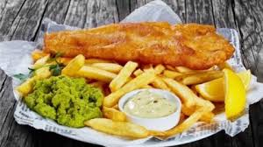
- Fish and chips – this traditional food contains fish and chips. The fish, usually cod, haddock or plaice, is dipped in batter and deep-fried; the chips are cut thicker than French fries and deep fried. Eat with salt and vinegar.
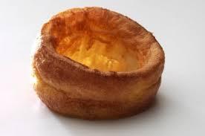
- Sunday roast – this British main food meal that is typically served on Sunday consisting of roasted meat, roast potato, and accompaniments such as Yorkshire pudding, stuffing, vegetables and gravy.
- Yorkshire pudding – is a common English side dish consisting of a baked pudding made from batter consisting of eggs, flour, and milk or water.
- Christmas dinner – in the UK is usually eaten in the afternoon on 25 December. The dinner usually consists of turkey (or duck, chicken, goose) served with stuffing, gravy, roast potatoes, and with dessert of Christmas pudding (or plum pudding).
- Pies – there are so many different pies in the UK, for example cottage pie (minced beef with a mashed potato topping), shepherd’s pie (using lamb instead of beef), etc.

Eating habits
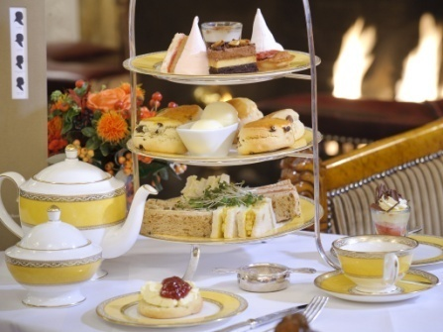
The British start their day with a hearty breakfast called Full English breakfast. This type of breakfast is usually consists of fried or grilled bacon, a sausage, a fried egg, baked beans, grilled tomatoes, a slice of fried bread. For lunch many people eat a sandwich. A ploughman's lunch is a traditional lunch for farmers: a bread roll, Cheddar cheese, pickle and salad, perhaps with a pork pie. For Britain was typical afternoon teatime. Today, a formal afternoon tea is more of a special occasion. Teatime is a light meal typically eaten between 3.30 pm and 5 pm. The food is often served on a tiered stand; there may be bread or scones with butter and jam, or toast, muffins or crumpets. Then is dinner, which consists of soup, main meal. Typical main meal is some meat with vegetable. Next is dessert and sometimes also cheese and biscuits.
American cuisine
American cuisine is very varied because colonization of the Americas brought about the introduction of a large number of new ingredients and cooking styles.
American traditional food
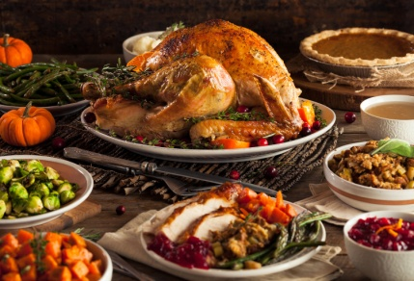
- Thanksgiving dinner – this dinner consists of turkey fill up with stuffing roasted in oven. It is served with a variety of side dishes such as mashed potatoes, and cranberry sauce. Thanksgiving dinner is the largest eating event in the United States; people eat more on Thanksgiving than on any other day of the year.
- Buffalo wings – these fried chicken wings doused in a cayenne-vinegar pepper hot sauce is ubiquitous bar snacks.
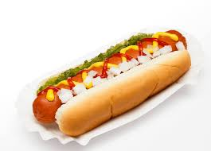
- Hot dog – is a grilled or steamed sausage sandwich where the sausage is served in bun. Typical condiments include mustard, ketchup, mayonnaise, and relish, and common garnishes include onions, sauerkraut, chilli, cheese, coleslaw, and olives.
- Hamburger – is a sandwich consisting of cooked meat, usually beef, placed inside a sliced sesame bun. The bun may be fried, grilled, or flame broiled. Hamburgers are often served with cheese, lettuce, tomato, onion, pickles, bacon, chilli, ketchup, mayonnaise or mustard.

Eating habits
Americans breakfast eggs, sausage and roasted bacon with toasts. The sweet variant of the breakfast are pancakes with maple syrup, waffles with whipped cream or toast with peanut butter. Americans eat lunch mostly in fast food. For lunch, eat burgers, pizza and especially sandwiches for example Grilled cheese sandwich or Bacon-Lettuce-Tomato sandwich. Dinner is the main meal of the day and usually makes it a salad, soup, fried chicken wings or fried potatoes, and the main meal is a hamburger again. Beans are also popular.

Useful terms and vocabulary
Terms
Gastronomy – The practice or art of choosing, cooking, and eating good food.
Food – Any nutritious substance that people or animals eat or drink or that plants absorb in order to maintain life and growth.
Meal – Any of the regular occasions in a day when a reasonably large amount of food is eaten.
Dish – A particular variety or preparation of food served as part of a meal.
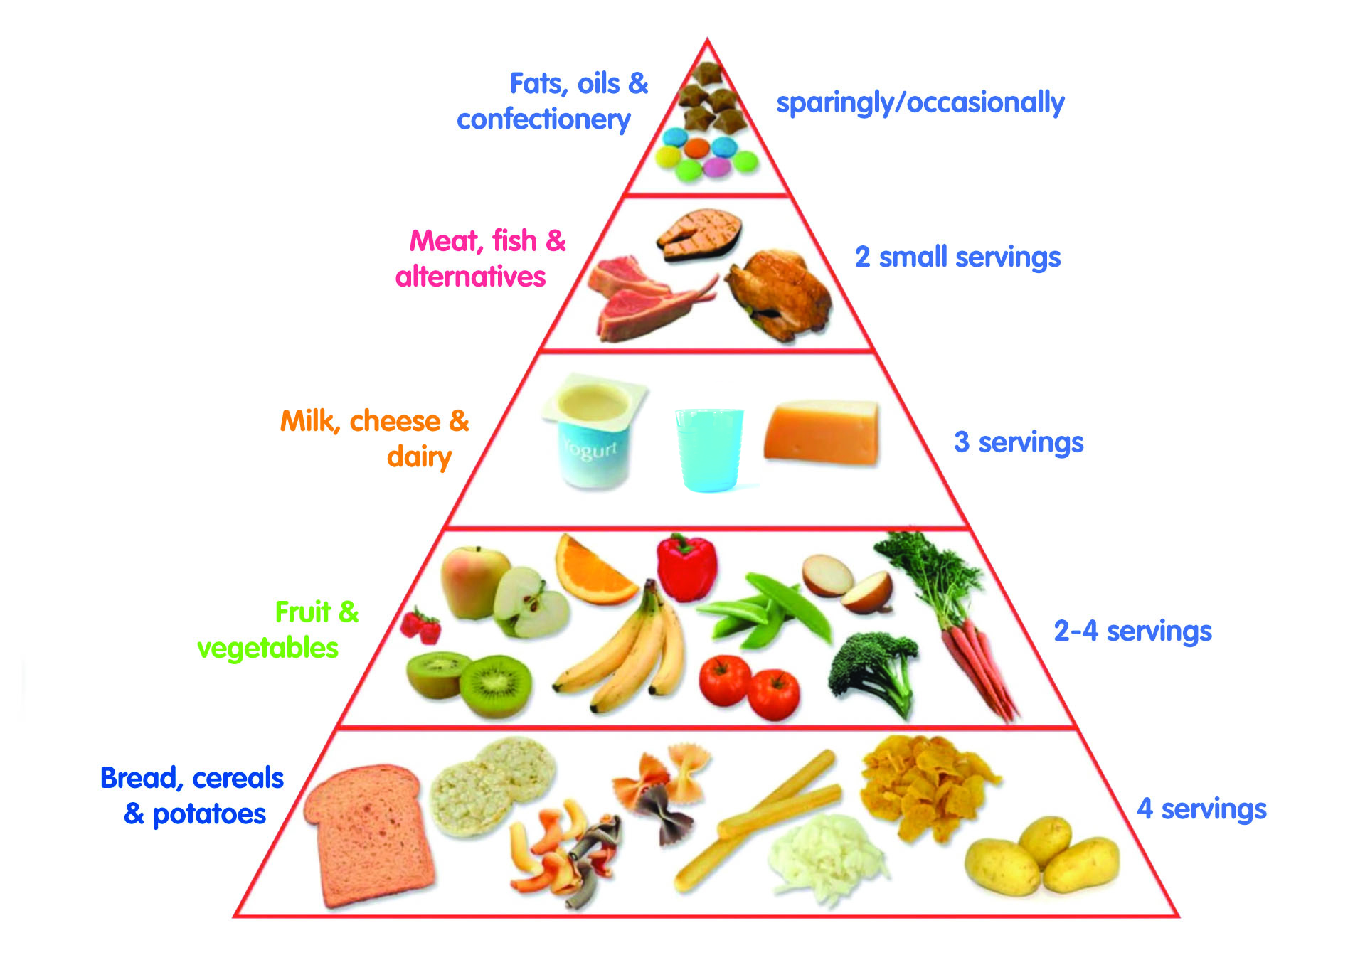
Vocabulary
Types of food:
- Sweets and fats
- Meat, fish and seafood
- Dairy products
- Fruit and vegetables
- Cereal products

Preparing food:
- Boil the eggs in a saucepan.
- Stir the soup with a wooden spoon.
- Bake for forty minutes in a hot oven.
- Mix all the ingredients in a bowl.
- Peel the potatoes.
- Slice the pineapple.
- Chop the parsley with a sharp knife.
- Melt some butter in a frying pan.

Vocabulary
cuisine | kuchyně
cabbage | zelí
braised | dušený
cranberry sauce | brusinková omáčka
haddock | treska
plaice | platýs
accompaniment | doprovod
gravy | omáčka
occasion | příležitost
ubiquitous | všudypřítomný
bun | houska
condiments | koření
maple syrup | javorový sirup
amount | množství
dairy products | mléčné výrobky

Recipe

Quick apple pie

Ingredients:
4 eggs
1 cup of sugar
1 spoon of cocoa
½ cup of oil
4 cups of chopped apples
2 cups of flour
Baking powder

Instructions:
- whisk eggs with sugar, cocoa and oil
- add chopped apples, flour and baking powder
- put dough on a baking sheet
- bake 20 minutes at 200°C

