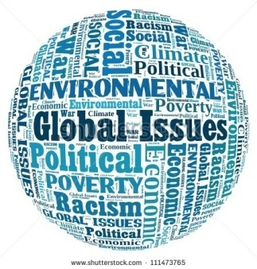
Global problems and environment
Global problems in general
Global issue is any issue that adversely affects the global community and environment, such as environmental issues, political crisis, social issues and economic crisis. Global issues range in severity from minor issues that affect everyone to global catastrophic risks that threaten the existence of the entire human race or its society. Solutions to global issues generally require cooperation among nations.
War
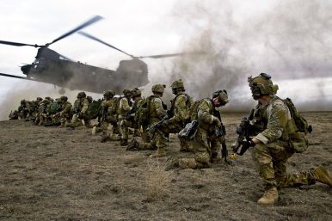
There were two WW (The term has been in use since at least as early as 1941. Some have applied it loosely to refer to limited or smaller conflicts such as the Cold War or the War on Terror) in the history of mankind, the first and the second (obviously). But nowadays, there is a potential for WW-III. Because of the development and use of nuclear weapons near the end of WW II and their subsequent acquisition and deployment by many countries, the potential risk of a nuclear devastation of Earth's civilization and life is a common theme in speculations of a Third World War. Another major concern is that biological warfare could cause a very large number of casualties.
Poverty
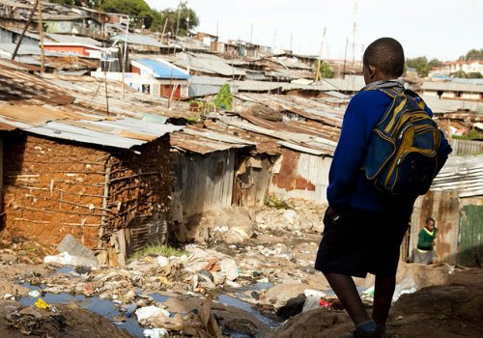
Poverty is a worldwide problem that produces many other problems. Poor people don’t often have enough food which can lead to starvation. Poor countries also don’t have a good health care system, that is also a very huge problem, people usually don´t live pretty long in these countries and the rate of approximate age of dying is way lower. We see these problems in many African countries as well as in Central American countries like Guatemala. People in Africa are exploited by huge companies, they had no control of their raw materials and crops, and they have no profit from it. Another problem of poor countries is education – there are no schools and people who aren’t educate can’t get a good job, so they can’t earn money and it has serious economic consequences (which can also lead to stealing – high criminal rate).

Human rights
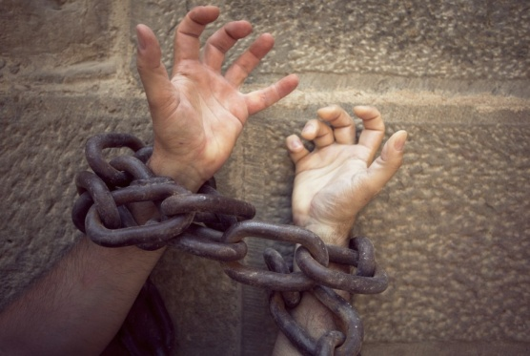
We all may be used to have our rights. We can do almost everything we want, we can have almost everyting we want. We have a right to speak, defend ourselves and many more. But there is a lot of people in the world who just simply don´t have their rights. They are being maltreated, harrased, oppressed by many and this is also one of the biggest problems (as example trafficking with human beings). It seems like the value of a humans life is lower in some countries, but life is precious no matter where we live. So we should help those people and fight for their rights too, cause one day we might lose ours.
Environment in general
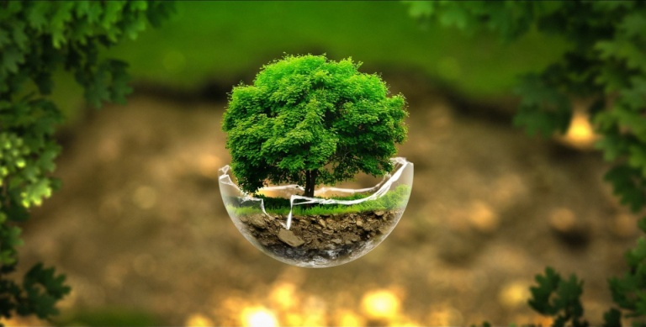
A biophysical environment is a biotic and abiotic surrounding of an organism or population, and consequently includes the factors that have an influence in their survival, development, and evolution. A biophysical environment can vary in scale from microscopic to global in extent. It can also be subdivided according to its attributes. Examples include the marine environment, the atmospheric environment and the terrestrial environment.
Pollution
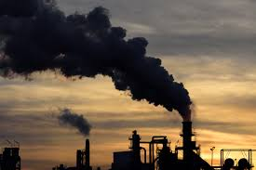
Pollution can be divided into variety of types. As example water, air or soil pollution. While water pollution is caused by oil spill, acid rain, urban runou, air pollution is caused by various gases and toxins released by industries and factories and combustion of fossil fuels. Soil pollution is majorly caused by industrial waste that deprives soil from essential nutrients.

Global Warming + climate change
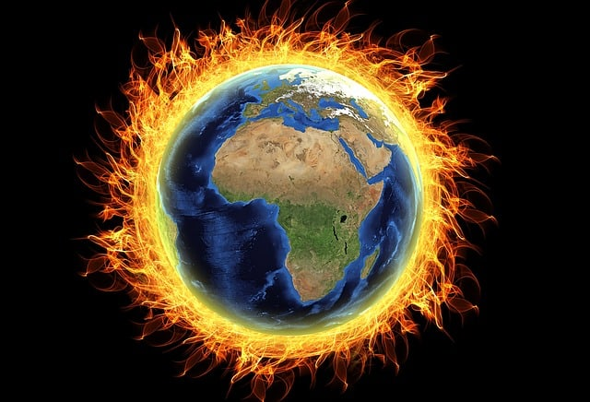
Global warming is a long-term rise in the average temperature of the Earth's climate system, an aspect of climate change shown by temperature measurements and by multiple effects of the warming. The term commonly refers to the mainly human-caused observed warming since pre-industrial times and its projected continuation, though there were also much earlier periods of global warming. Many of the observed warming changes since the 1950s are unprecedented in the instrumental temperature record. Future climate change and associated impacts will differ from region to region.

Ongoing and anticipated effects include:
- rising sea levels
- changing precipitation
- and expansion of deserts in the subtropics

Future warming is expected to be greater over land than over the oceans and greatest in the Arctic, with the continuing retreat of glaciers, permafrost, and sea ice.

Other likely changes include more frequent extreme weather events such as:
- heat waves
- droughts
- wildfires
- heavy rainfall with floods
- and heavy snowfall
- ocean acidification
- and massive extinctions of species due to shifting temperature regimes

Because the climate system has a large "inertia" and greenhouse gases will remain in the atmosphere for a long time, many of these effects will persist for not only decades or centuries, but tens of thousands of years.

Waste disposal
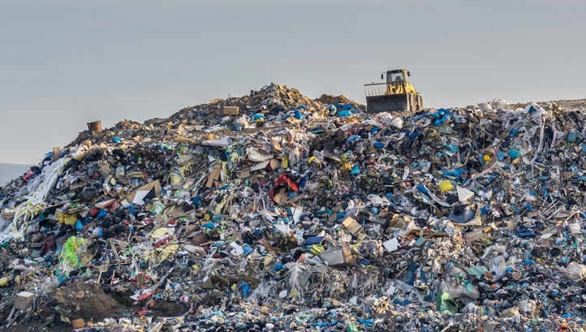
Waste disposal is one of urgent current environmental problems. The over consumption of resources and creation of plastics are creating a global crisis. Nuclear waste disposal has tremendous health hazards associated with it. Plastic, fast food, packaging and cheap electronic wastes threaten the human beings and also to animals. Many animals worldwide die becasuse of plastic packagings and so on. People should consider using less plastics and go „zero waste“.
Deforestation
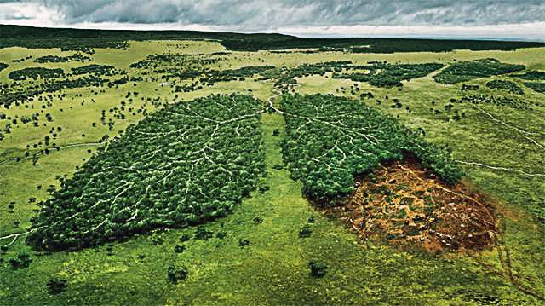
Our forests are natural sinks of carbon dioxide and produce fresh oxygen as well as it helps in regulating temperature and rainfall. At present forests cover 30% of the land but every year tree cover is lost amounting to the country of Panama due to growing population demand for more food, shelter and cloth. Deforestation simply means clearing of green cover and make that land available for residential, industrial or commercial purpose. This is a very serious issue cause forests not just produce high amount of oxygen, but it also helps absorb / stop water. Without forests there is a high risk of bigger floods.
Ideas for improvement
To be honest, there is not a single way how to improve those conditions. However, each problem needs different solution and there are not really the easy ones. People mostly go with „I can´t make the difference alone“, but if everyone says that, we are all doomed and destined to inevitable death. (as a human kind of course). We should all think about this and try to do our best to provide our future offsprings safe and clean environment.
Vocabulary:
Issue
Lack of
Human rights issues
Malnutrition
Starvation
Environmental issues
Droughts
Floods
Pollute
Dump waste
Maltreat
Provide
Offspring
Mankind
Warfare
Acquisition
Deployment

https://en.wikipedia.org/wiki/Global_issue (direct citation)
https://en.wikipedia.org/wiki/Biophysical_environment (direct citation)
https://en.wikipedia.org/wiki/Global_issue
https://en.wikipedia.org/wiki/Zero_waste

